**MURAL 3** Nestucca Bay Creamery depicts Jersey cows owned by local farmers in the Nes­ tucca Valley. This creamery that makes cheese, has a factory across the river. It is owned by a family that settled in South Tillamook County over 100 years ago. Visit the Creamery, see more historical photos & enjoy some home­ made ice cream.

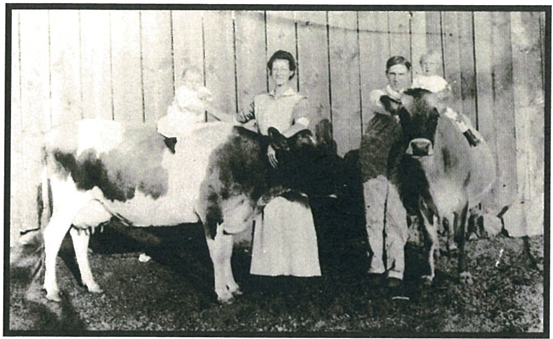

**MURAL 4** The building in front of you was the home to Noble Bittner Plug Mill for many years. The 1906 Cloverdale School mural depicts stu­ dents from grade 1- 12. A high school was built on top of the hill in 1929, and a one-room schoolhouse dotted South Tillamook County for younger children.

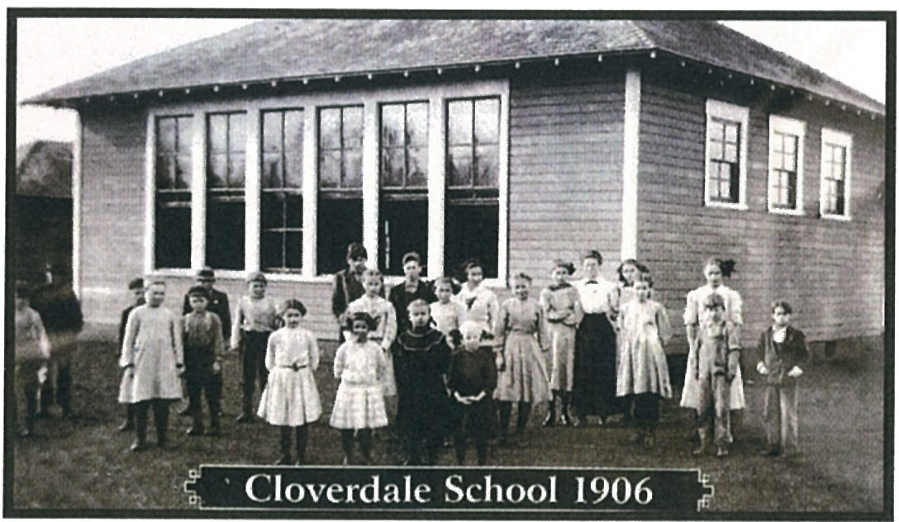

**MURAL 5** Highway 101was one named the Roose­ velt Highway by President Roosevelt, who began the Pacific Coast Highway in 1941.

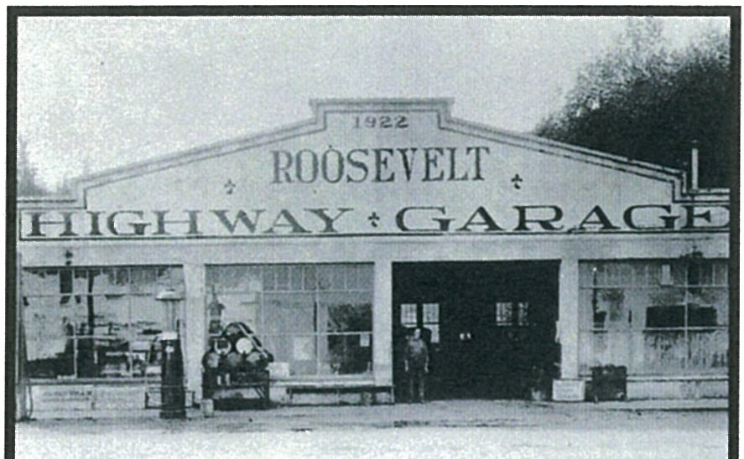

**MURAL 6** Cloverdale had a Cash Market and then the Hall's Grocery Store, where the current Turkish Rug Store is today. Lloyd McKillip delivered meat & supplies throughout South Tillamook County as a young man.

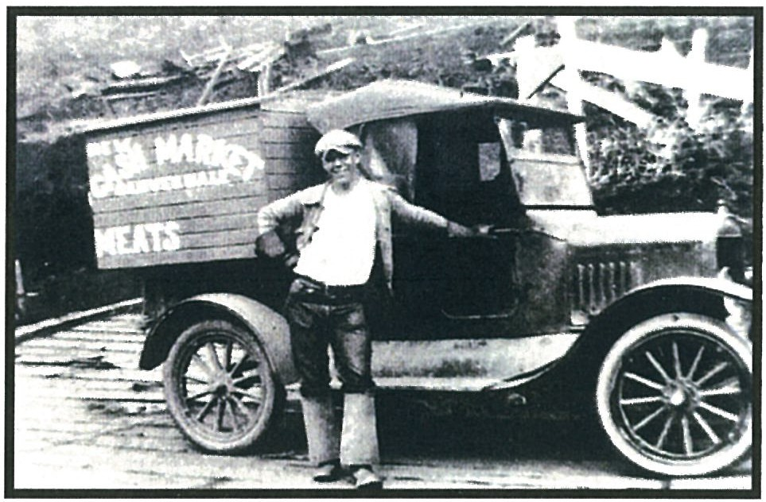

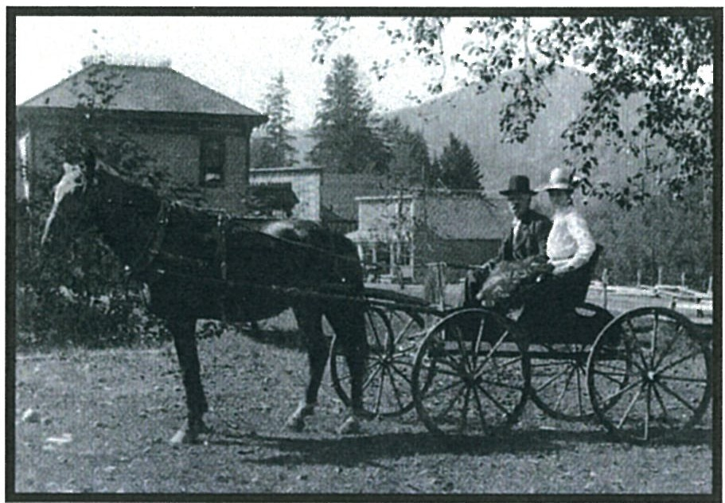**MURAL 7** On the post office building, this 1920 Cloverdale bus picked up mail & passengers in front of the Cloverdale Post Office in the Kraner Building.

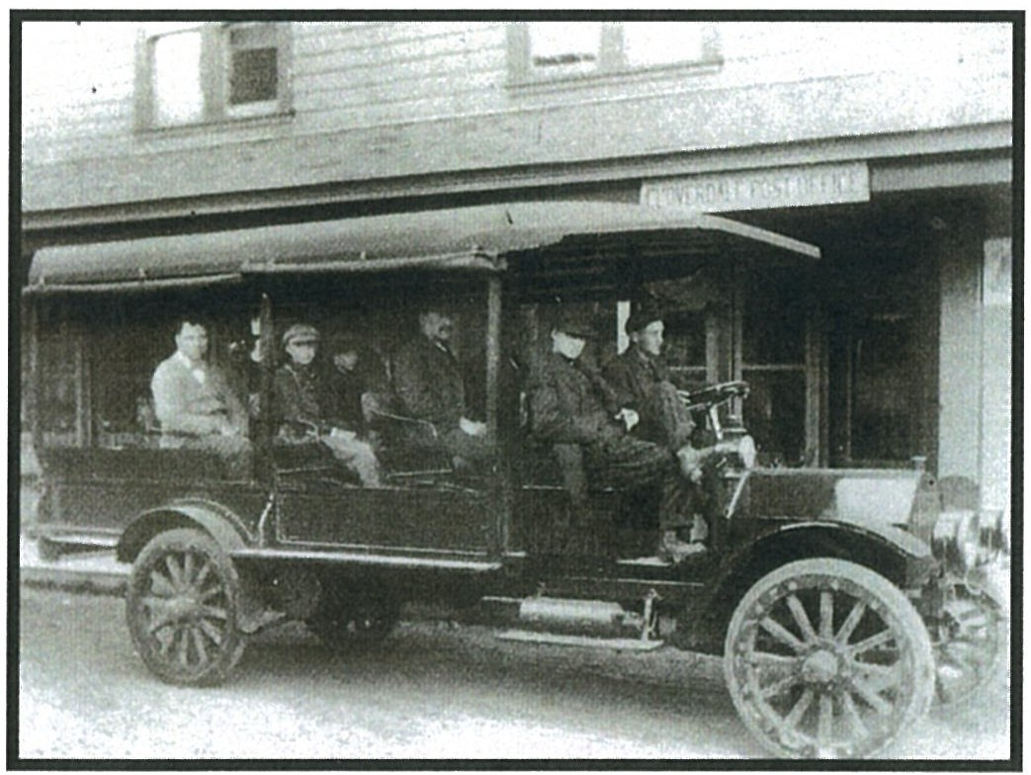

# *CAREFUL CROSSING THE HIGHWAY*

**MURAL 8** One block up Bridge Street is St. Joseph's Catholic Church, built in 1924 to serve a Swiss immi­ grant community. They raised the money to build the church, including beau­ tiful stained glass windows.

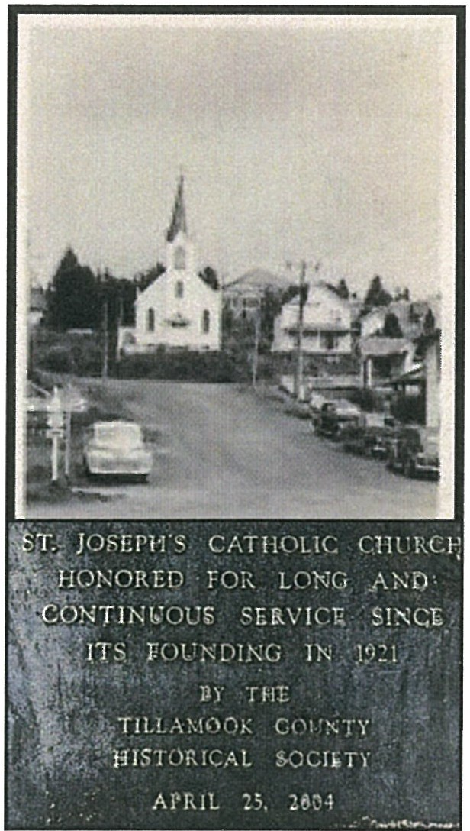The bridge crossing the Nestucca River was once a beautifully covered bridge. This road leads to the town of Woods & back over the River to Pacific City.

**MURAL 9** The valley was filled with many small dairy farms that sold their milk to the Cloverdale Cheese Factory. Each day, the milk was hauled to the factory by horse & buggy in milk cans.

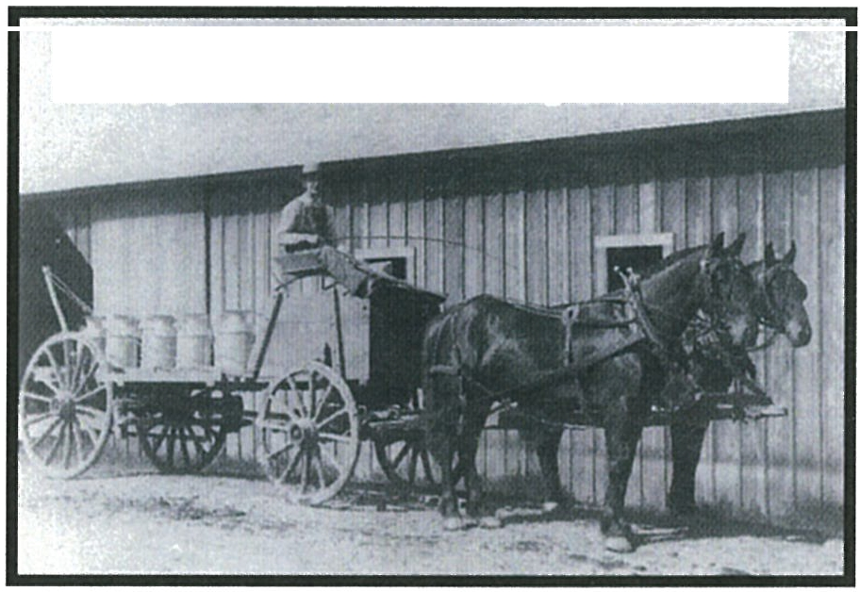

Bill Messner qelivet'in his milk

**MURAL 10** The newly renovated Charles Ray house has a sign on the south side, showing Charles Ray with his horse & buggy out for a Sunday ride with Millie lier. There was a barn next door where he kept his horses & mules.

**MURAL 11** This mural on the present garage depicts the transition from horse & carriage to the presence of cars in the area.

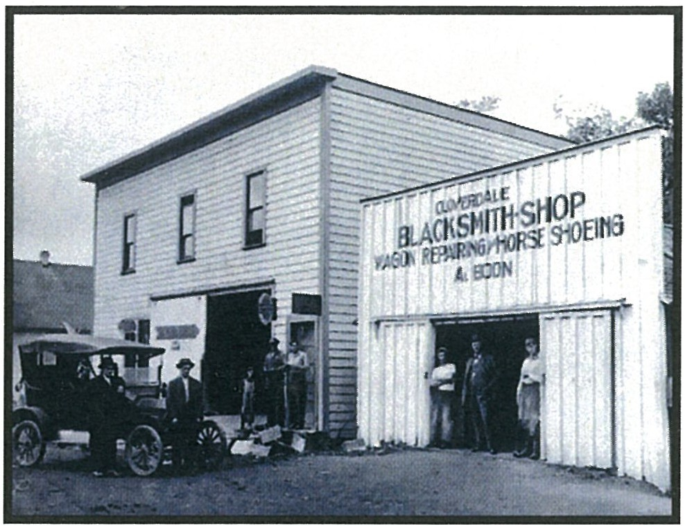

**MURAL 12** Tillamook County Feed Store has been in this location since the early 195o's, supply­ ing farmers with needed supplies. The Tillamook Creamery owns the store & sells Tillamook Cheese & other dairy products.

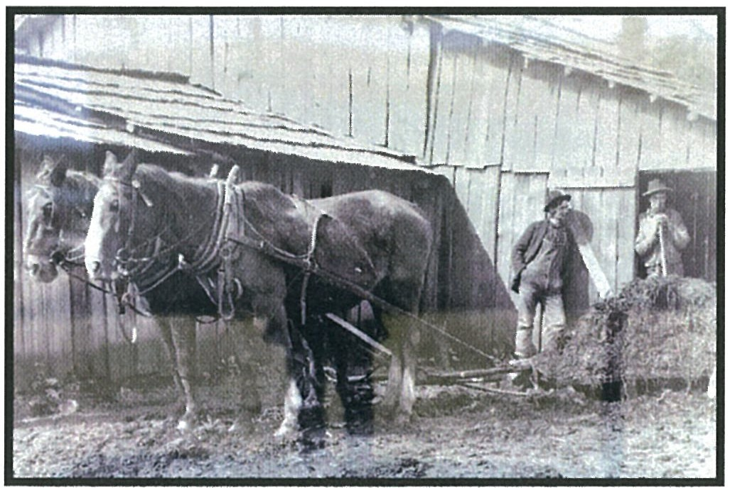

**Thank you**

**for allowing us to share our Cloverdale history.**

**Please be careful returning to the county parking lot.**

*1·*

The **Tillamook County Historical Society (TCHS)** was founded in 1984 to bring together those interested in preserving Tillamook County's History & to discover & collect materi­ als with the help of interpreting & illustrating that history. The organization has spent many years placing informational plaques on historic buildings & sites in Tillamook County. We have conducted field trips & walking tours of down­ town Tillamook buildings & historic homes. We have been publishing out-of-print books that highlight early life in Tillamook. These books are available on our website & at the Tillamook Pioneer Museum.

The **TCHS** meet at the main Tillamook Library on the second Tuesday of each month at 1 pm. Dues: $20.00 a year

$200.00 Lifetime membership (supports our publishing projects)

Website. **Tillamookhistory.com**

Mailing address **TCHS P.O. Box 123**

**Tillamook, Oregon 97141**

**HISTORY OF CLOVERDALE**

**r, llllllil\\i;;;I**Cloverdale was founded by

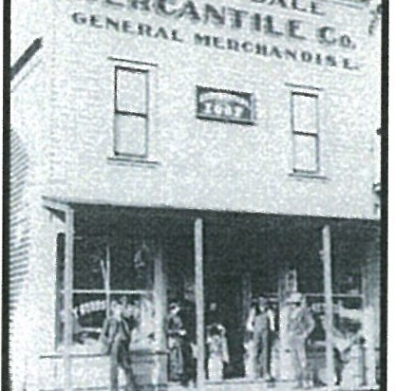Charles Ray, who came to the area in 1884 to file a claim for land next to his fa­ ther, Lester. Charles estab­ lished a store, hotel, bank,

i.i;;:;=::;:::: and cheese factory.

He also built a dock on the Nestucca River to receive goods by boat for his businesses. His house still stands in the center of the town.

In 1920, a fire burned many buildings along the riverside of town. Charles Ray built a new town hall that was 65 feet long and had a movie theatre, dance hall, basketball court, skating rink, & stage with curtains. This town hall building burned down in 1934.

Along the river are a series of buildings with

**Enjoy the half mile loop/walking tour, view­ ing 12 historical photo murals starting from the county parking lot on the north side of Cloverdale on the riverside to the current­ Post Office. Return on the opposite side of the street to view the remaining murals.**

***********

**MURAL 1** is a map of the Nestucca River from its source as it flows through small towns to the Pa­ cific Ocean. This 52-mile river was the home to the Nestucca natives for over 12 thousand years. It was their source of transportation and food.

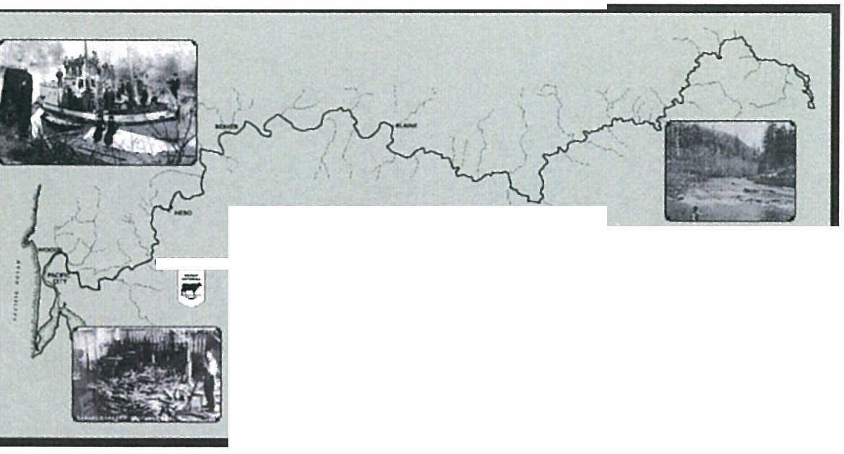

aovw,.ua === ,?-.::;.. :::::=. . ====:. '"

**The NESllJCCA RIVER**

; ; = ;;; .;_

.... *:=:.·:::.- =.::...* **;:::.·.:::=::..7**

* -------

shops that have changed names and owners

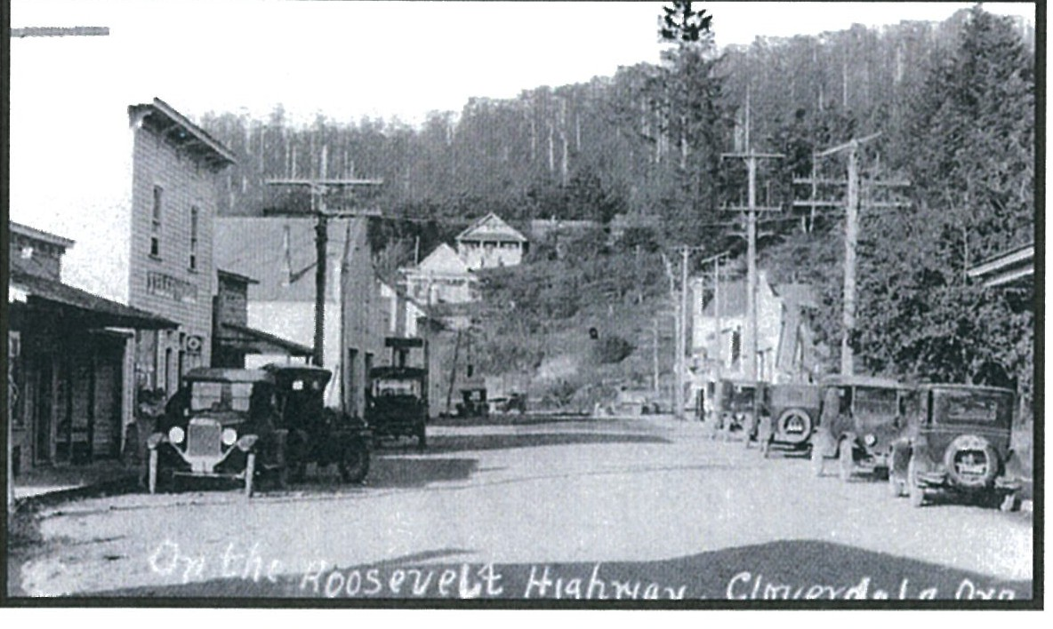

Most of these historical pictures were taken by Clyde Hudson, who documented early life in Tillamook County. Photos are part of the Lorraine Eckhardt Collection.

The Walking Tour brochure was developed to help celebrate Cloverdale history.

Sponsored by -

**Tillamook County Historical Society Tillamook Travel**

**Oregon Coast Visitors Assn.**

**South Tillamook County Library-Pacific City**

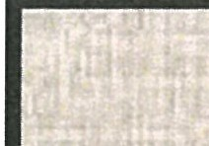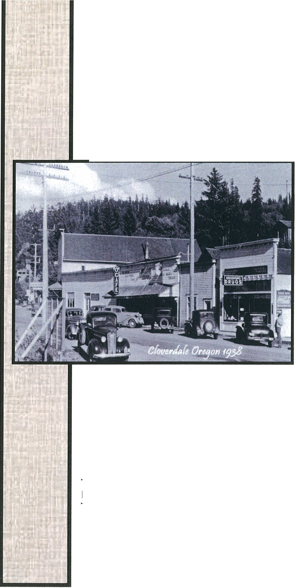

II

**WALKING TOUR OF CLOVERDALE**

**OREGON**

**TILLAMOOK COUNTY HISTORICAL SOCIETY**

**P.O. Box 123**

**TILLAMOOK, OREGON 971 41**

**MURAL 2**

Salmon were so abundant in the Nes­

June 2024

over the years. The Rusty Cow was once a drugstore & pharmacy. Cloverdale is once again rising from the ashes with new busi­ nesses and is ready to serve residents & visi­ tors for years to come.

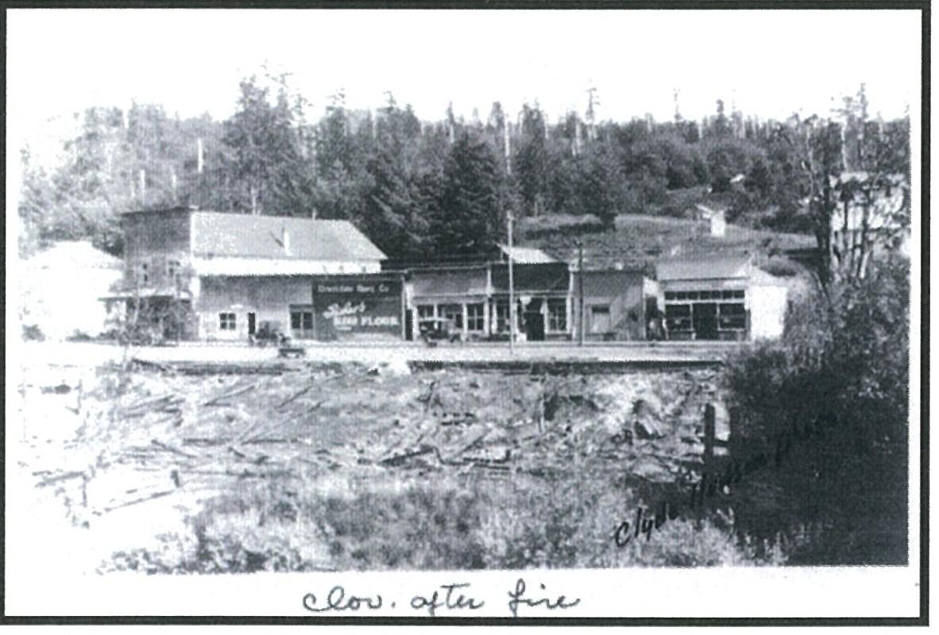

tucca River that new settlers could provide for their families year-round. A cannery at the Nestucca Bay was a source of income for many farmers.

